Lab Report 1: CoAP Client

For this lab, a CoAP Client was developed. It was tested using coap.me public test server. The following features were implemented: **POST**/**PUT**/**GET**/**DELETE.**

# Explanation:

Every method message is defined in a function, with only a few parameters changing for every method, for example for the GET method:

After that, the message is created by concatenating the elements

Here, all the binary parameters for the message are defined

The message is then sent using a UDP socket and a response is recovered:

This response is parsed using the payload delimiter (11111111 in binary) to get the header but most importantly the contents of the response.

The main program is using a continuous loop with a menu that lets a user choose the method.

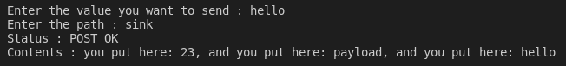When an option is chosen (POST for example), the program asks for more information to send the request and displays the status of the request. For POST and PUT, a get is done immediately after to confirm the value was correctly registered in the path.

We can also look at the packets in Wireshark to get more details and see that they are correctly formed:

# Improvements:

A few nice to have features that were not mandatory for this project would be:

* To support long path names such as: .well-known/core;
* To let the user chose the URL or IP address of the server he wants to connect to;
* To implement block transfer to receive long messages;